Practice Questions DLD 1

Question#1 Determine the Truth table for each of the following expressions.
Question#2

Question#3 Using k-map, find the simplified expressions.
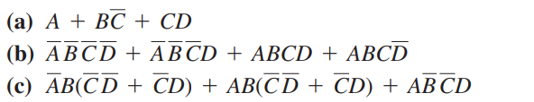

Question#4 Draw a combination circuit with three inputs x, y, z and three outputs A, B, C. When the binary input is 0, 1, 2, or 3, the binary output is one greater than the input. When the binary input is 4, 5, 6 or 7, the binary output is one less than the input.

Question#5: Apply Demorgan’s law to following expressions and write equivalent expressions.
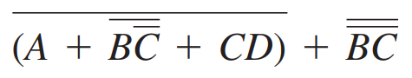
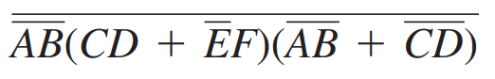
a. b.

Question#6: Reduce the combination logic circuit to minimum form.

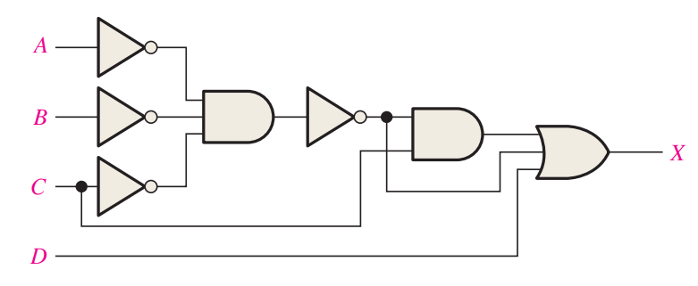

Question#7 : Implement the following expressions using Using NAND gates only.

